**Exp. No : 10**

# VISUALIZE DATA USING ANY PLOTTING FRAMEWORK

**1. Scatter Plot**

# Install ggplot2 (if not already installed) install.packages("ggplot2") # Load the ggplot2 package library(ggplot2)

# Scatter plot of Sepal.Length vs Sepal.Width, colored by Species ggplot(data = iris, aes(x = Sepal.Length, y = Sepal.Width, color = Species)) + geom_point(size = 3) + # Adds points labs(title = "Scatter Plot of Sepal Dimensions", x = "Sepal Length (cm)", y = "Sepal Width (cm)") + # Adds axis labels and title theme_minimal() # Applies a minimal theme

**Output :**

Scatter Plot of Sepal Dimensions

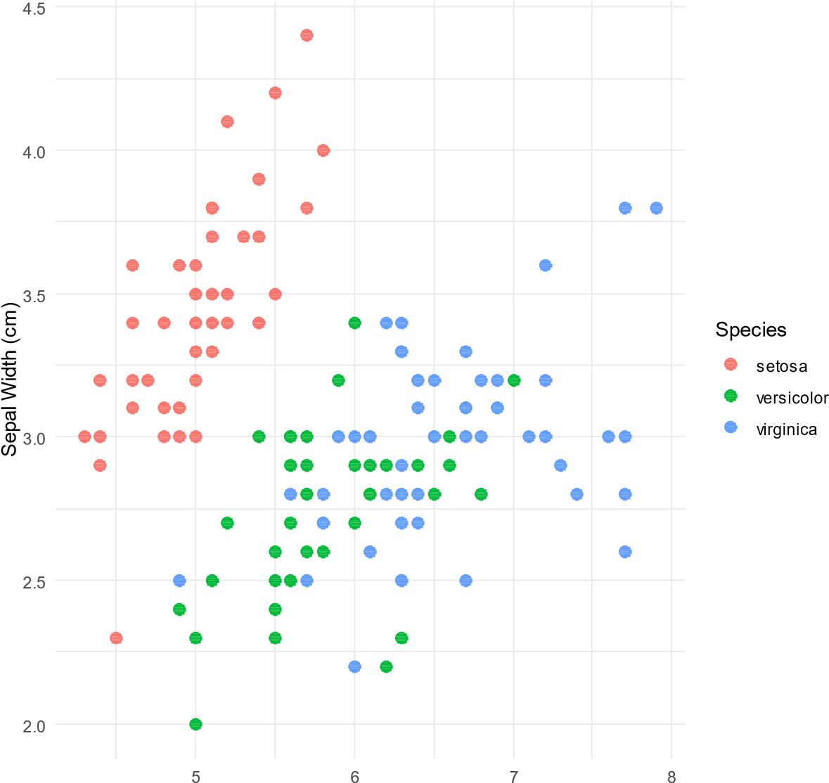

Sepal Length (cm)

**Bar Chart**

# Load the ggplot2 package library(ggplot2)

# Bar plot of Species counts ggplot(data = iris, aes(x = Species)) + geom_bar(fill = "steelblue") + # Adds bars filled with steel blue color labs(title = "Count of Different Species in Iris Dataset", x = "Species", y = "Count") +

theme_minimal()

**Output :**

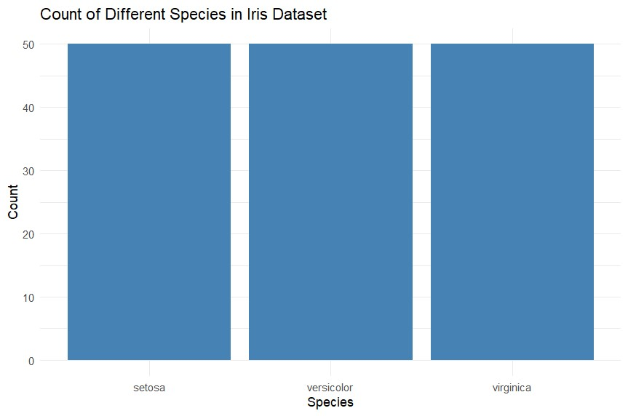

**Histogram**

# Load the ggplot2 package library(ggplot2)

# Histogram of Sepal Length ggplot(data = iris, aes(x = Sepal.Length)) + geom_histogram(binwidth = 0.3, fill = "orange", color = "black") + # Adds histogram bars labs(title = "Histogram of Sepal Length", x = "Sepal Length (cm)", y = "Frequency") + theme_minimal()

**Output :**

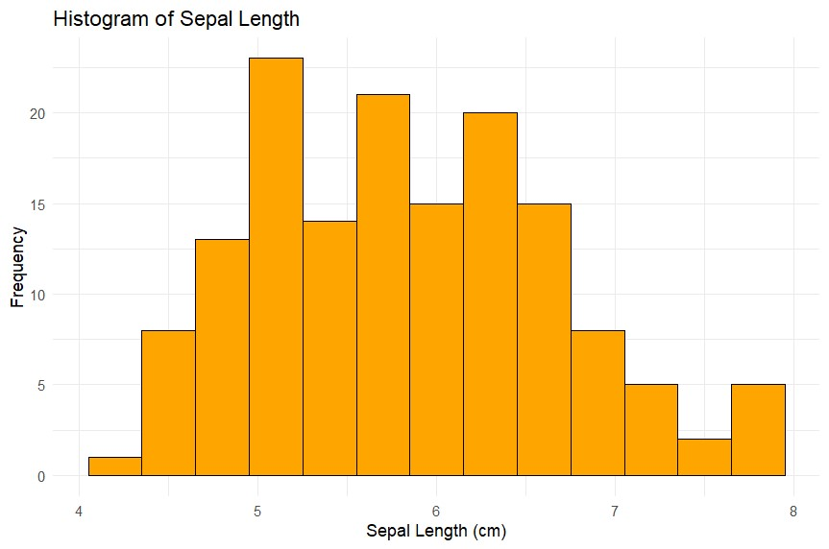

**Box Plot**

# Load the ggplot2 package library(ggplot2)

# Box plot of Sepal Length for each Species ggplot(data = iris, aes(x = Species, y = Sepal.Length, fill = Species)) +

geom_boxplot() + # Adds box plot labs(title = "Box Plot of Sepal Length by Species", x = "Species", y = "Sepal Length (cm)") +

theme_minimal()

**Output :**

